Experiment-3
Program:
import cv2
# Read image
img = cv2.imread("image.jpg")
# Convert to grayscale
gray = cv2.cvtColor(img, cv2.COLOR_BGR2GRAY)
# Apply Canny edge detection
edges = cv2.Canny(gray, 100, 200)
# Display images
cv2.imshow("Original Image", img)
cv2.imshow("Edge Detection", edges)
cv2.waitKey(0)

cv2.destroyAllWindows()
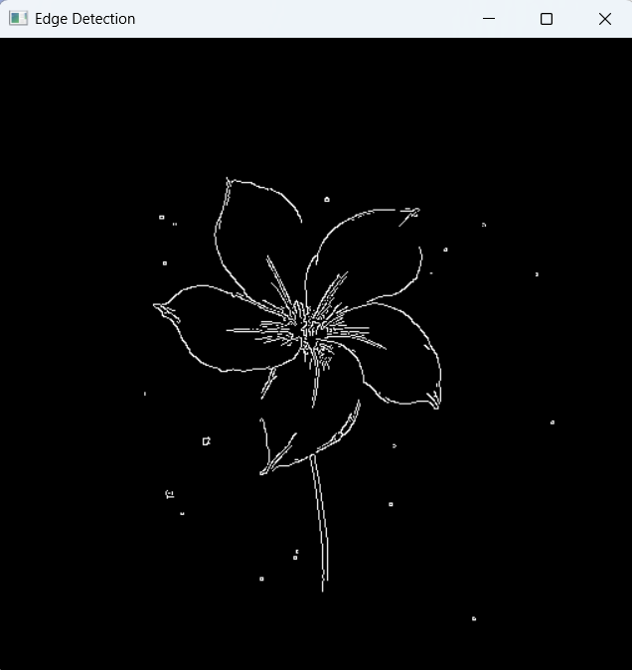
Input: Output:

